**1. Retrieve the total number of order placed.**



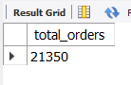

**2. Calculate the total revenue generated from pizza sales.**

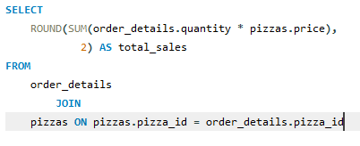

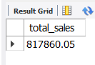

**3. Identify the highest price pizza**

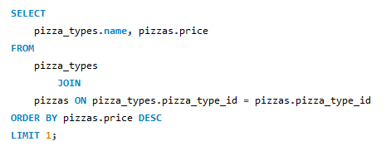

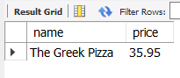

**4. Identify the most common pizza size ordered.**

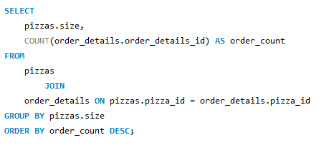

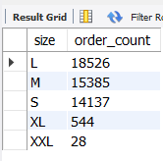

**5. List the top 5 most ordered pizza types along with their quantities**

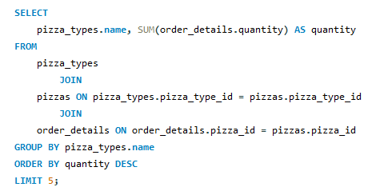

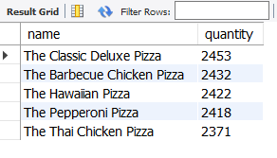

**6. Join the necessary tables to find the total quantity of each  
pizza category ordered.**

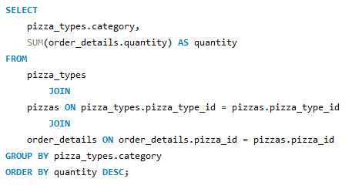

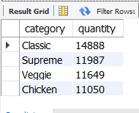

**7. Determine the distribution of orders by hours of the day.**

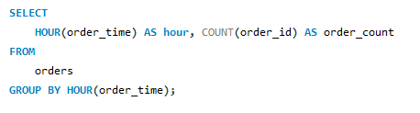

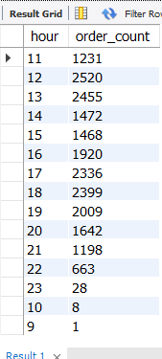

**8. Join the relevant tables to find the category wise distribution of pizzas.**

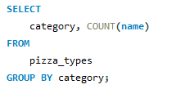

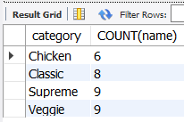

**9. Group the orders by date and calculate the average numbers of pizzas ordered per day**

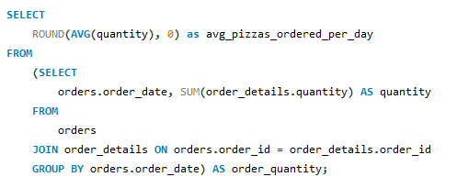

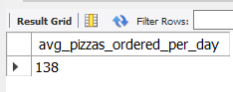

**10. Determine the top 3 most ordered pizza types based on revenue.**

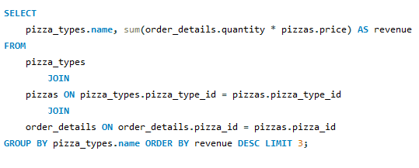

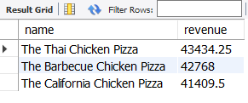

**11. Calculate the percentage contribution of each pizza type to total revenue.**

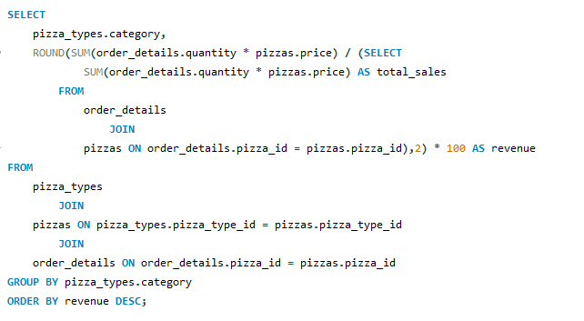

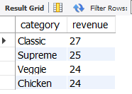

**12. Analyze the cumulative revenue generated over time.**

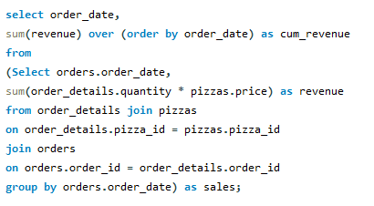

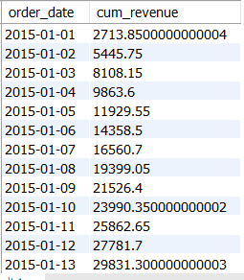

**13. Determine the top 3 most ordered pizza type based on revenue for   
each pizza category.**

